Inspiring Journey of our Solopreneurs

"I have not failed. I've just found 10,000 ways that won't work."
-Thomas Alva Edison
Taking inspiration from the quote above and to know more about the different ways to tackle business problems and create innovative solutions, the Toronto Chapter of the World Zarathusti Chamber of Commerce (WZCC) gathered on Saturday at the Zoroastrian Society of Ontario, Toronto for a day of networking and to listen to the Entrepreneurial journey of two dynamic solopreneurs.
PARSI FOOD BY Percy
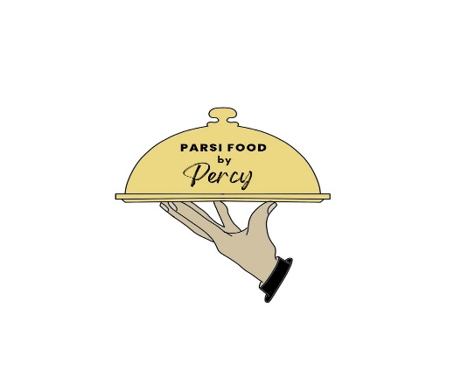
Percy Daruwala, who is the founder of Parsi Food by Percy in Toronto took us through a gastronomical journey of the intricacies of preparing delicious Parsi Food, loved by one and all.
He spoke about the difficulties he had to face growing up and how his determination and passion led him to successfully starting this culinary venture, making his father proud.
One of the key challenges that he spoke about in the modern era that he encountered in his business was his lack of awareness of using social media as a means of promoting his brand along with taking orders. He talked of how his daughter, Tasheen, who now runs the venture with him, helped him to create social media platforms to interact with existing and potential customers, thereby expanding the venture across the Greater Toronto Area (GTA).
This session was concluded with Q&A’s where the audience wanted to understand how he manages to deliver orders across the GTA.
We gathered immense guidance and understanding of the restaurant and catering business through Percy’s pearls of wisdom.

FROM DARK TO LIGHT
The next speaker, Alexandra Marcovich, who is the co-founder of From Dark to Light carpet cleaning services shared some interesting insights about his journey from entering the carpet cleaning business and how he met his co—founder due to being fed up of the 9—5 Corporate Life, to the fine details on how to clean a carpet in the correct manner.
Some of the ways to keep a carpet clean is to vacuum it daily in order to avoid dust being accumulated on the carpet. In case of a stain, it would be advisable to use a carpet cleaning liquid and remove it immediately so that the stain does not permanently imprint itself on the carpet.
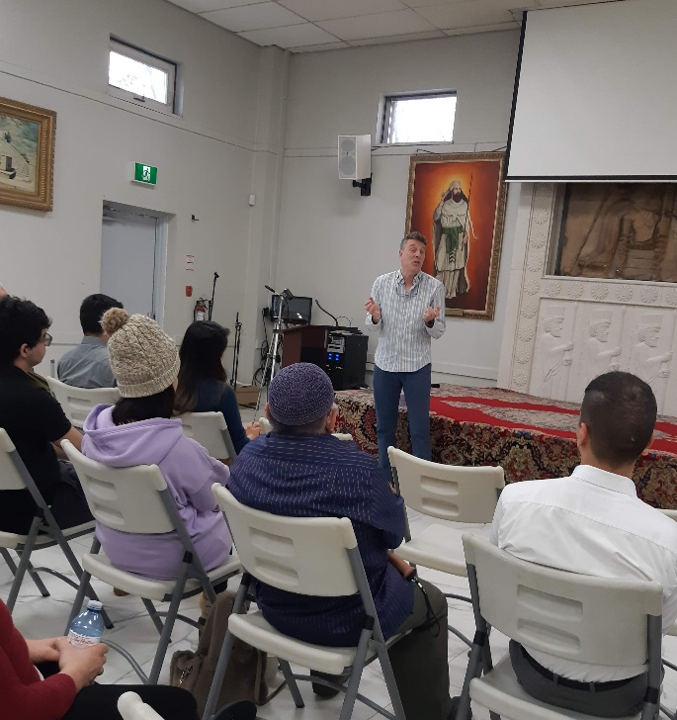

He concluded the session by speaking about different type of carpets and how important is the hiring of professional carpet cleaners, especially in the cleaning and maintenance of carpets on commercial complexes.
His talk was followed by Q&A where the audience were interested to know how they promote their business and accept carpet cleaning jobs along with the estimate for each job.
The session was enjoyed by one and all and broke up for our tea and snack session.

Ventures of the speakers can be viewed by clicking on the following links:
Parsi Food by Percy Daruwala
From Dark to Light by Alexandra Marcovich

